

PRACTICAL -9
Graph Traversal: Depth-First Search and Breadth-First Search

Practical Aim
To implement depth-first and breadth-first traversal on a graph and develop the ability to reason about how the order of exploration changes depending on the traversal strategy used.

Problem 1
A disaster relief team needs to inspect all buildings in a city after an earthquake. The city is mapped as a network where buildings are connected by roads. One team starts at a building and goes as deep into each road as possible before backtracking, while a second team spreads out level by level — first checking all buildings directly connected to the start, then all buildings two roads away, and so on. Given the city map as a graph and a starting building, implement both exploration strategies and print the order in which buildings are visited by each team.
Describe how the order of buildings visited differs between the two strategies on the same graph. What data structure does each strategy rely on to decide which building to visit next, and how does that structure cause the difference in order?
CODE LINK:
https://github.com/nishee166/FDSA-Batch--B-SHP-.git

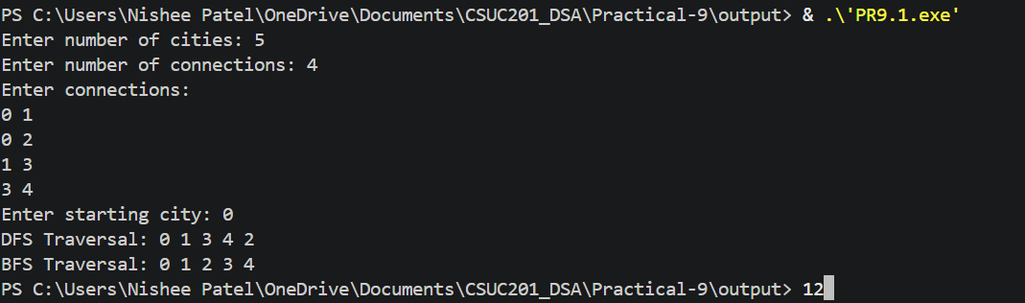

Error Faced:
I initially forgot to reset the visited array before running BFS, so BFS printed nothing after DFS had already marked all nodes as visited.
Learning:
I learned how DFS uses recursion (a stack) and BFS uses a queue, and how the visited array stops nodes from being visited more than once.
Solution:
I reset all values of the visited array to 0 before calling each traversal function.
Key Questions:
Problem 1
Both strategies visit every reachable node exactly once. If the goal is simply to check whether a specific building exists in the network, which strategy would find it sooner if the building is very close to the start? What if it is very far and deep? Explain your reasoning without tracing through any specific example.

ANS:
If the building is very close to the start, BFS finds it sooner because it checks all nearby buildings level by level first. If the building is very far and deep, DFS can find it sooner because it goes deep along a road directly, while BFS must first visit all the buildings at the earlier levels.

Problem 1
Your DFS implementation likely uses recursion. What real-world constraint on the computer could cause your recursive DFS to fail on a very large city map, and how would you restructure your solution to avoid that failure?

ANS:
Recursive DFS uses the system call stack, which has limited memory. On a very large city map the recursion can become too deep and cause a stack overflow. To avoid this, DFS can be written iteratively using an explicit stack of our own, which is stored in heap memory and can hold many more nodes.

Conclusion
The practical successfully implemented depth-first and breadth-first traversal on a graph. I learned how DFS uses a stack (recursion) and BFS uses a queue, how the visited array prevents revisiting nodes, and how this changes the order in which nodes are visited.

